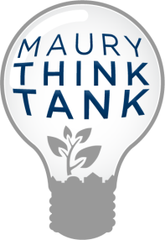 August 28, 2014
Dear Maury Thinkers!
Welcome to an exciting, new school year. This year we have so many wonderful Think Tank and STEM ( Science, Technology, Engineering and Math) initiatives planned. From our Think Tank lending library to school-wide studies, this year is already packed with engaging activities. Our students continue to shine as thinkers and learners and I look forward to seeing them grow even more this year! Please read the Think Tank FAQs below and feel free to contact me with any questions for comments. I look forward to working with your child ( and hopefully you too) this school year!
Yours thoughtfully,
Vanessa Ford
Think Tank and STEM Coordinator
Vanessa.ford@dc.gov
http://maurythinktank.blogspot.com
Twitter: @maurythinktank
What is Think Tank?

Think Tank is an inquiry-based class that helps students learn to think and solve problems! Using the Habits of Mind (http://instituteforhabitsofmind.com) and based in Multiple Intelligence theory, students complete standards based challenges and projects that allow them to explore content in a variety of ways. Think Tank also ensures that all students are receiving instruction aligned with the newly adopted Next Generation Science Standards (www.nextgenscience.org).

When will my child have Think Tank this school year?
MONDAYS | TUESDAYS | WEDNESDAY | THURSDAYS | FRIDAYS
Jaikaran | Timmons  Dorsey  Cooper  Battle  Duckett (4th) | Wright-Spurlock  Hipps  Fox  Vick  5th Grade (all) | Mitchell  Donnelly  Sparrow | Levin  Fitzpatrick  Setash

What partnerships and special programs will there be this year?
We are so lucky to have such wonderful partners in the STEM world! Each of these program enrich the regular science and engineering classes held in Think Tank.
Partnerships and Trips:
- Anacostia Watershed Society will partner with 1st - 5th grades.
- Living Classrooms: 3rd – 5th grades
- Architects in the Schools: 4th grades
- Labyrinth Puzzles and Games: Game Design: 3rd grade
Engineering Programs :
- Engineering is Elementary : Each grade level will complete one of these great units! Visit www.eie.org
- A World in Motion: Kindergarten and 2nd grades
- SeaPerch Underwater Robotics: 5th grade
There’s a back---------------:)

Schoolwide Programs:
- Monarch Madness: Fall 2014
- SHAD Restoration: May 2015
- Think Tank and STEM Expo: March 12th, 2015
- Labyrinth Puzzles and Game Lending Library: Opening October 2015
What are the expectations for behavior in Think Tank?
Think Tank is a space where I expect students to collaborate, inspire teamwork, take risks in their learning and ask questions. In order to ensure that this is all done safely, especially with all of the materials we use, I have four basic rules:
- Actively listen to the person who is speaking.
- Keep hands, feet and mean words to yourself.
- Use materials safely and appropriately.
- Use positive words and voice.
If a student is not meeting these expectations the following steps will happen:
- Receive a warning.
- Move to the “Think and Reflect” space in the room
- Go to a buddy class teacher
- Call home or to the Assistant Principal
Does Think Tank need volunteers?
I always welcome volunteers! We address many areas of science and engineering throughout the year. If this is your field of work, or you just want to join the learning you are welcome any time. Please just email me to set it up!
What is happening at my child’s grade-level this year in Think Tank?
Grade-level specific letters will go home in Tuesday folders in the coming weeks. This will have more detailed information on the new science standards at your child’s level and what units I will be teaching in Think Tank. It will also lay out the timeline for special events and volunteer opportunities specific to each grade level. Stay tuned!
What are the Habits of Mind?
Habits of Mind are the things that good problem solvers and thinkers do! These are skills like any academic skill and can be taught, practiced and learned. Each class, our project has a Habit of Mind focus along with any content we are learning.
The Habits of Mind are:
* Listen Actively * Contribute Positively to the Group and Inspire Teamwork * Understand others
* Think Interdependently * Set Goals and Make Plans * Persevere
*Look Carefully * Use What You Know- Transfer Learning * Communicate Clearly
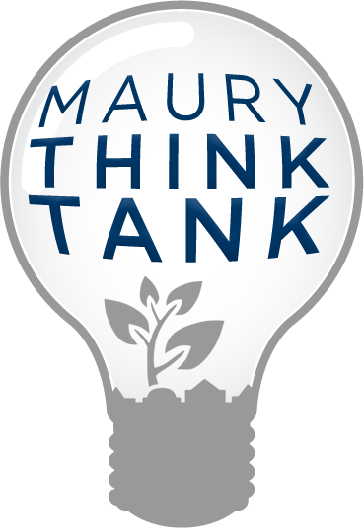
*Wonder, Explore and Ask Questions * Be Adventurous and Open-Minded
* Strive to be Accurate and Precise * Step Back and Look at the Whole Picture
* Imagine Possibilities and Outcomes * Think Independently

